CCC 510 / DES 211
CREATIVITY AND CONCEPT IN DESIGN

PROJECT REPORT

PORTABLE
WORK STATION

SUBMITTED BY:

DANIEL DAVID VAZ: 1710110097
KABIR KANHA ARORA: 1710110165
MEGHNA GHOSH: 1710110213

MENTOR:

Dr PARTHA CHATTERJEE

(Signature)

ACKNOWLEDGEMENTS

Since you’re here, we’d like to take this opportunity to extend our heartfelt gratitude to the university and Professor Amit Ray for a wonderful opportunity. We truly enjoyed the course and what it taught us. We’d like to thank our project guide, Dr Partha Chaterjee, for his ceaseless support and guidance throughout the course of the semester. We would also like to thank Sanjoy sir, Karan sir and the OCJ students. This project would not have been possible without their able guidance and expertise.

- Objective (Problem identification)

Our fixed study tables come with a lot of limitations. Sometimes we feel the desk is too low, sometimes we feel it’s too high. Other times we wish the table could be angled in a manner so that it’s easy for us to sit back comfortably, even in the comfort of our beds, and read a book or work on our laptops. Proper posture while working is extremely important and discomfort while working or improper posture can lead to several health-related problems, especially in the back and neck.

Another problem with desks, especially for students is that the small things like books, stationery, etc. have to regularly organized. Apart from this, some limitations with our laptops itself is that when they’re placed on regular desks, they often overheat and shut down. Lastly, most desks don’t come with lights. Hence, we have to switch on the lights of the entire room which might disturb a sleeping roommate. In such a situation, it becomes extremely difficult to work on laptops without backlit keyboards or read and write, as you might have to strain your eyes.

Keeping all these problems in mind, we devised a portable work station, with several features aimed at fixing the above problems. We decided to make it as small and light as possible, so that it can be carried around anywhere we want to work, keeping all the work things together. On collapsing it, it could even fit into a big bag.

Therefore, we came up with the following characteristics for our Portable work station:
- Adjustable height.
- Adjustable angle.
- Perforations.
- Keyboard lighting.
- Drawer for stationery.
- Space for books.
- Special drawer for your phone where it can stand vertically or horizontally and get charged at the same time.
- Simplicity and portability.

- Research on the topic:

- Competitors: To understand whether our product is unique and desirable, we had to check the available and already existing products in the market. On doing our research, we saw the following products to be readily available in the market in different prices according to the quality of the product and materials used:
- Desk organizers with several drawers.
- Desk organizers to arrange and organize small things into compartments.
- Wire organisers.
- Laptop stands with ventilation.
- Portable desks.
- Fixed work stations (desks/study tables).
- Laptop stands with adjustable height/angle.

We will notice that, not only is our product unique, but also a combination of all of the following products. Thereby, it solves several problems and maximizes utility at a cheaper price.

- Market Survey: To understand the market, we must identify the requirements and problems of people. To do this, we conducted a google survey. Since our main target is students, we conducted a survey among the students of Shiv Nadar University on a random basis. We also sent it across to family and relatives, as we felt all working people who mostly work on their laptops will also find our product extremely useful.
The following questions were asking in the survey:

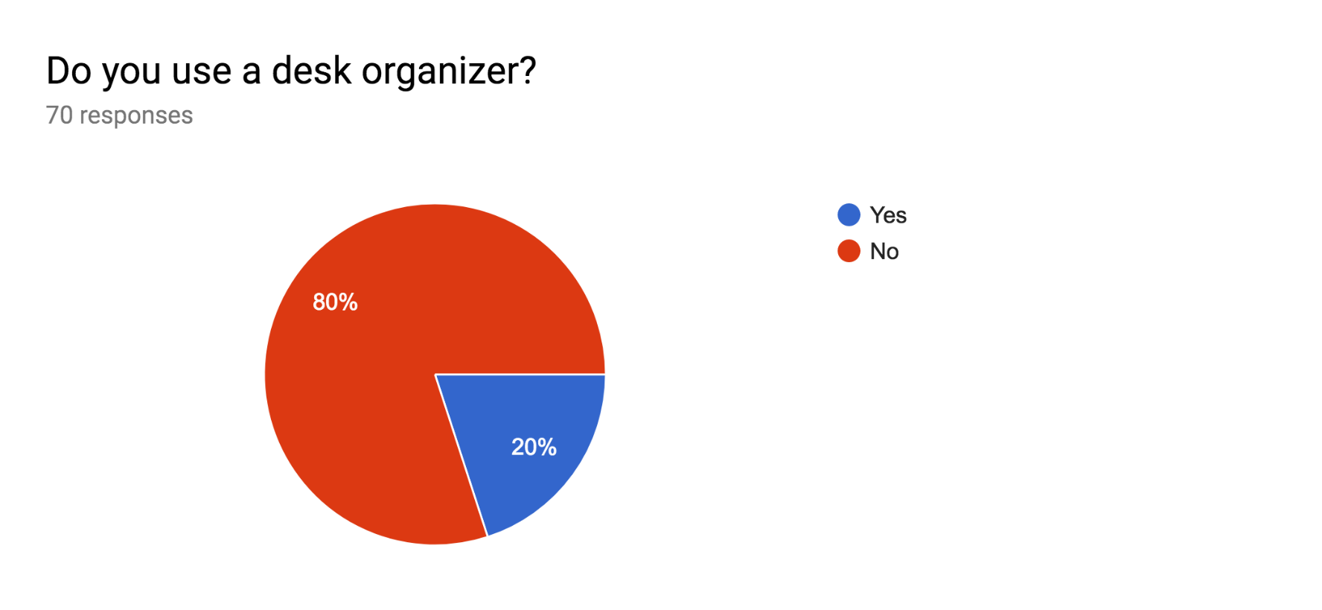

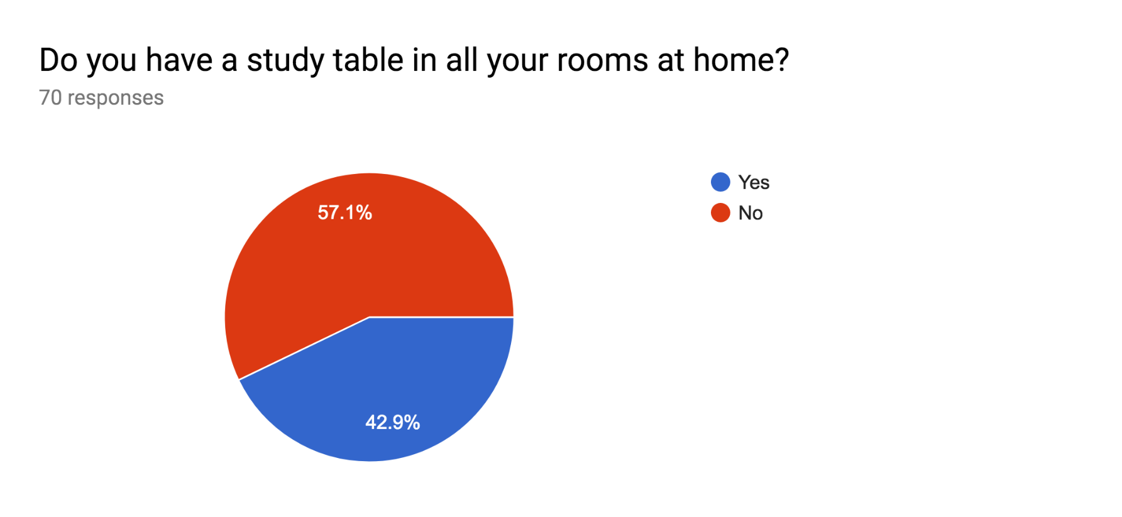

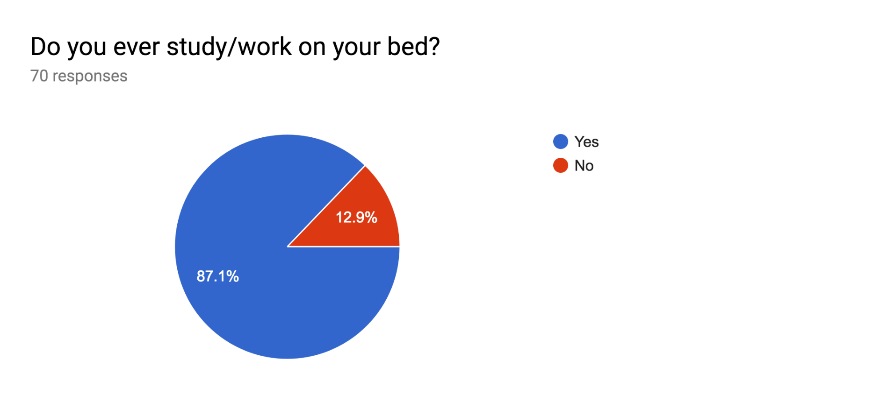

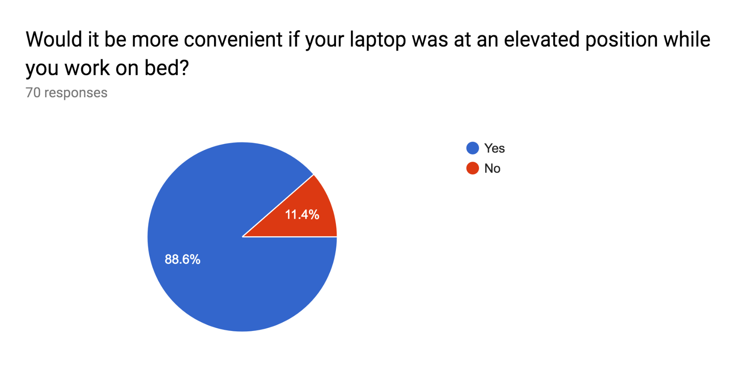

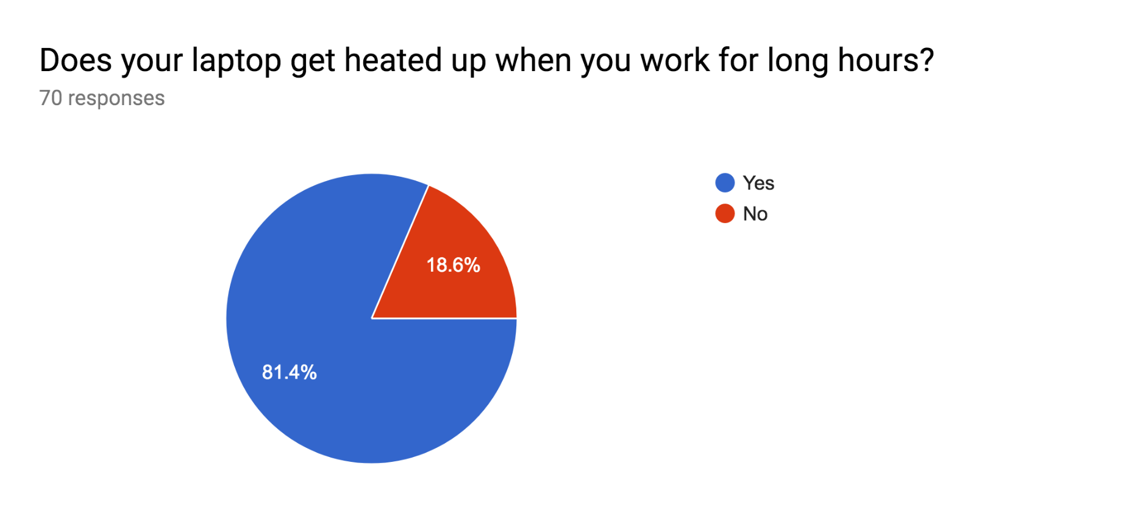

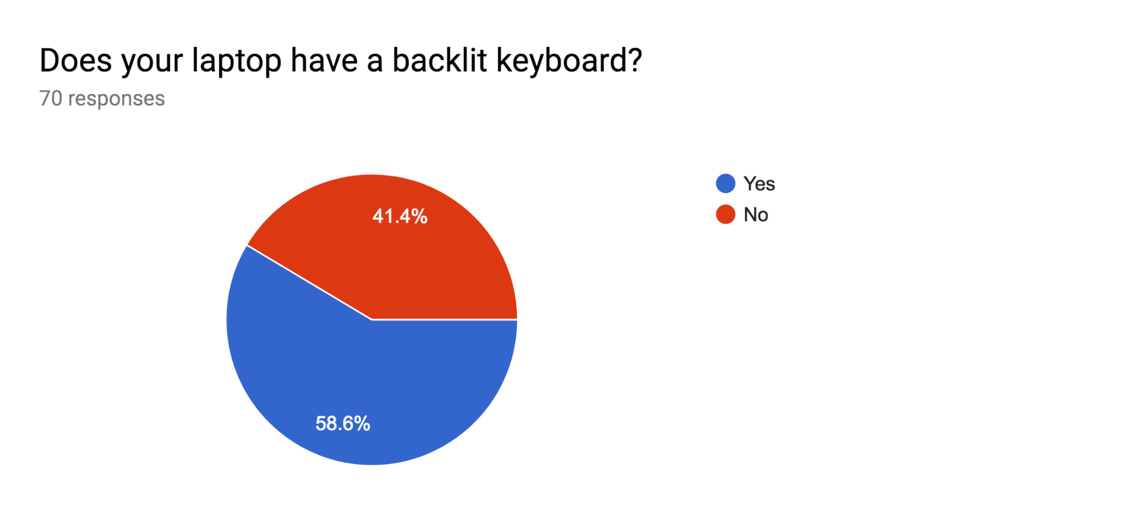

Would you want an all in one portable work station with a laptop/book stand with ventilation that can be adjusted according to any height and angle of your choice, drawers to store everything you work with, and a place to keep and organize all your wires so you can continue your work anywhere you want without everything getting disorganized?

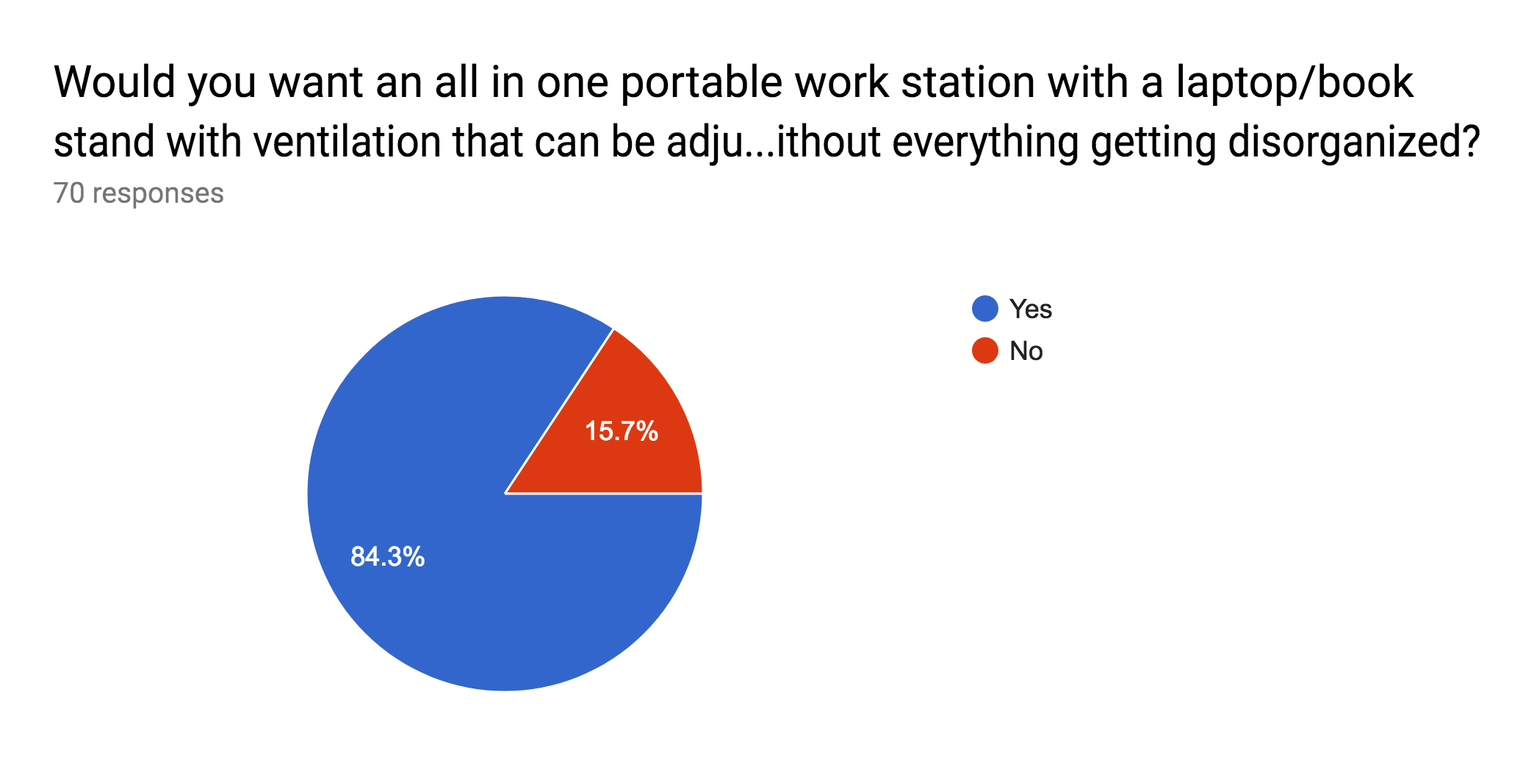

Analysing the survey, we made the following observations:
- Although most people don’t use a desk organizer, the same people love the idea of our product.
- The problems we identified were confirmed by the survey.
- The only exception to this is that most people already have laptops with backlit keyboards. Hence, although an added feature it might not be completely useful to everyone.

- Concept Generation with sketches:

- Hand drawn sketches
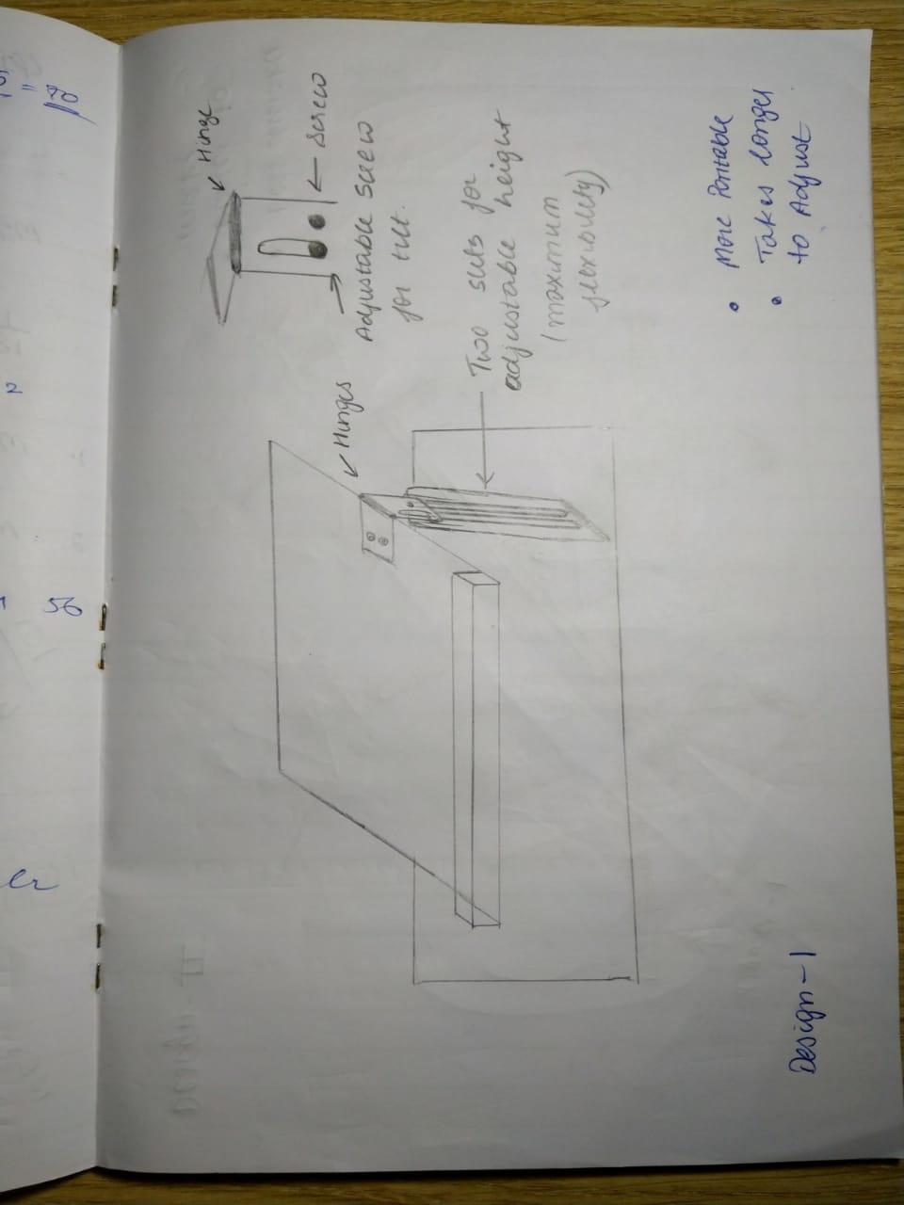
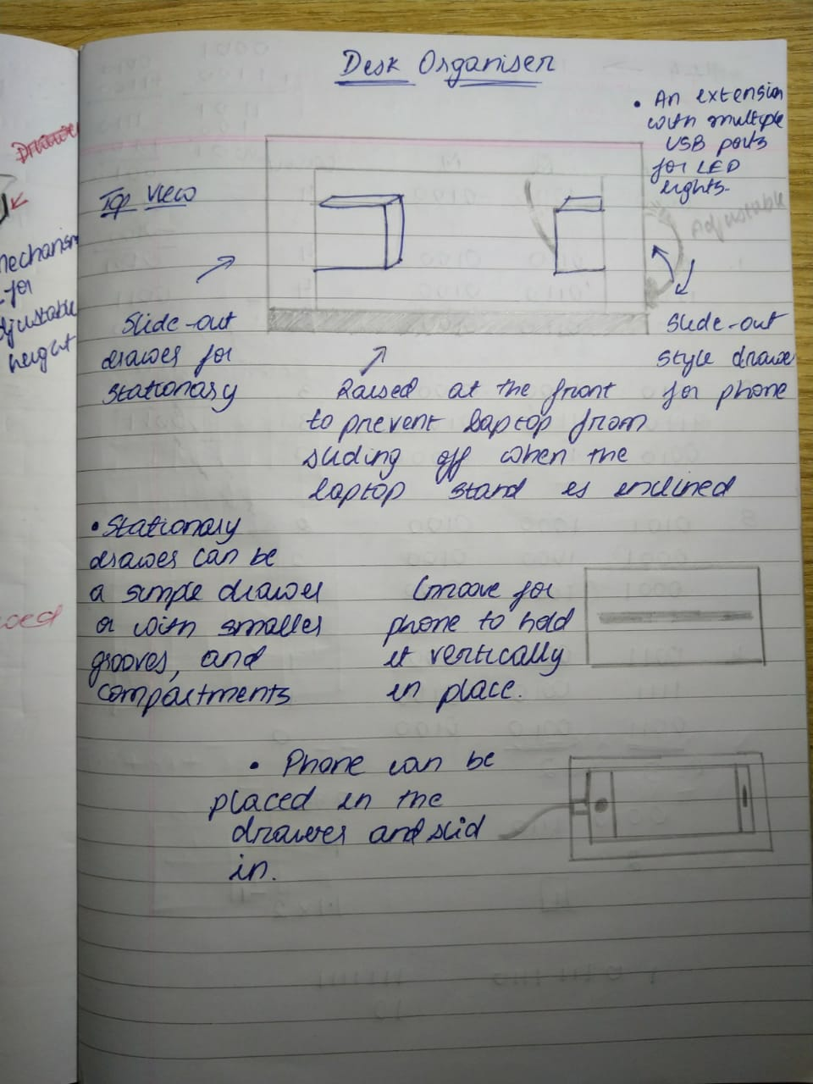
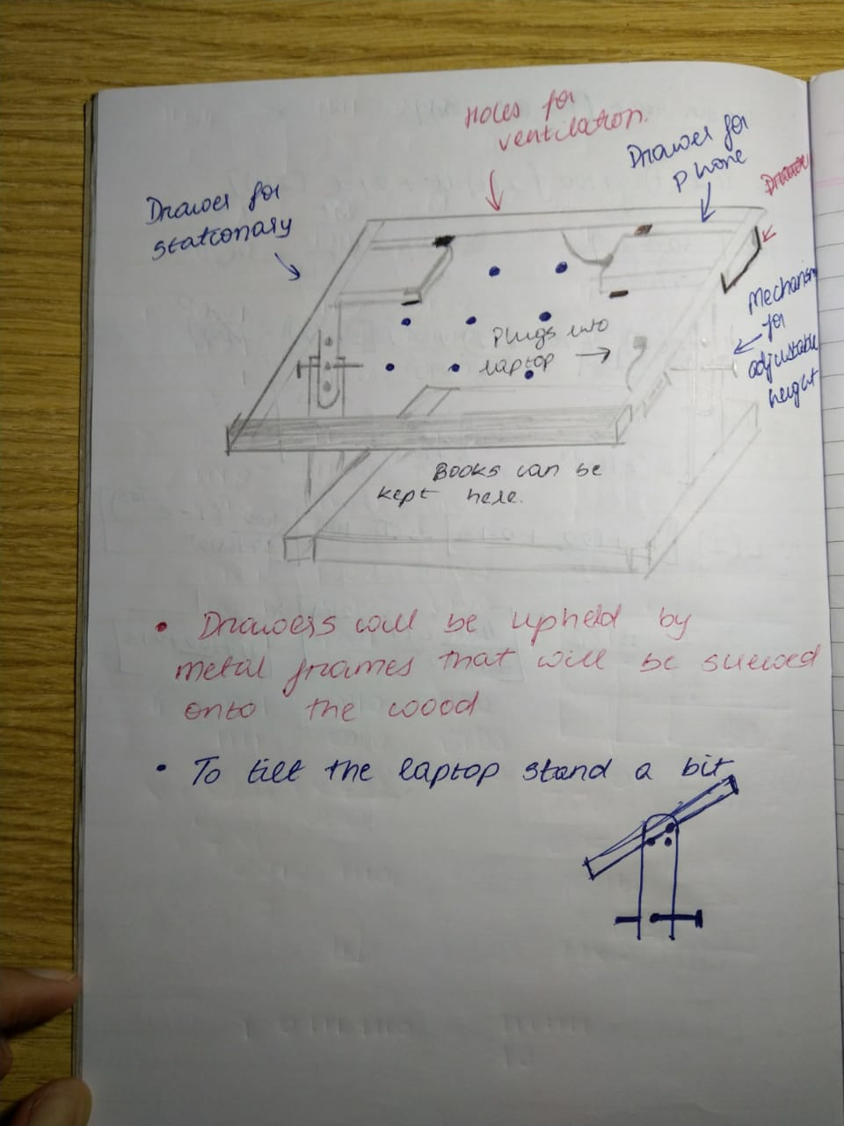

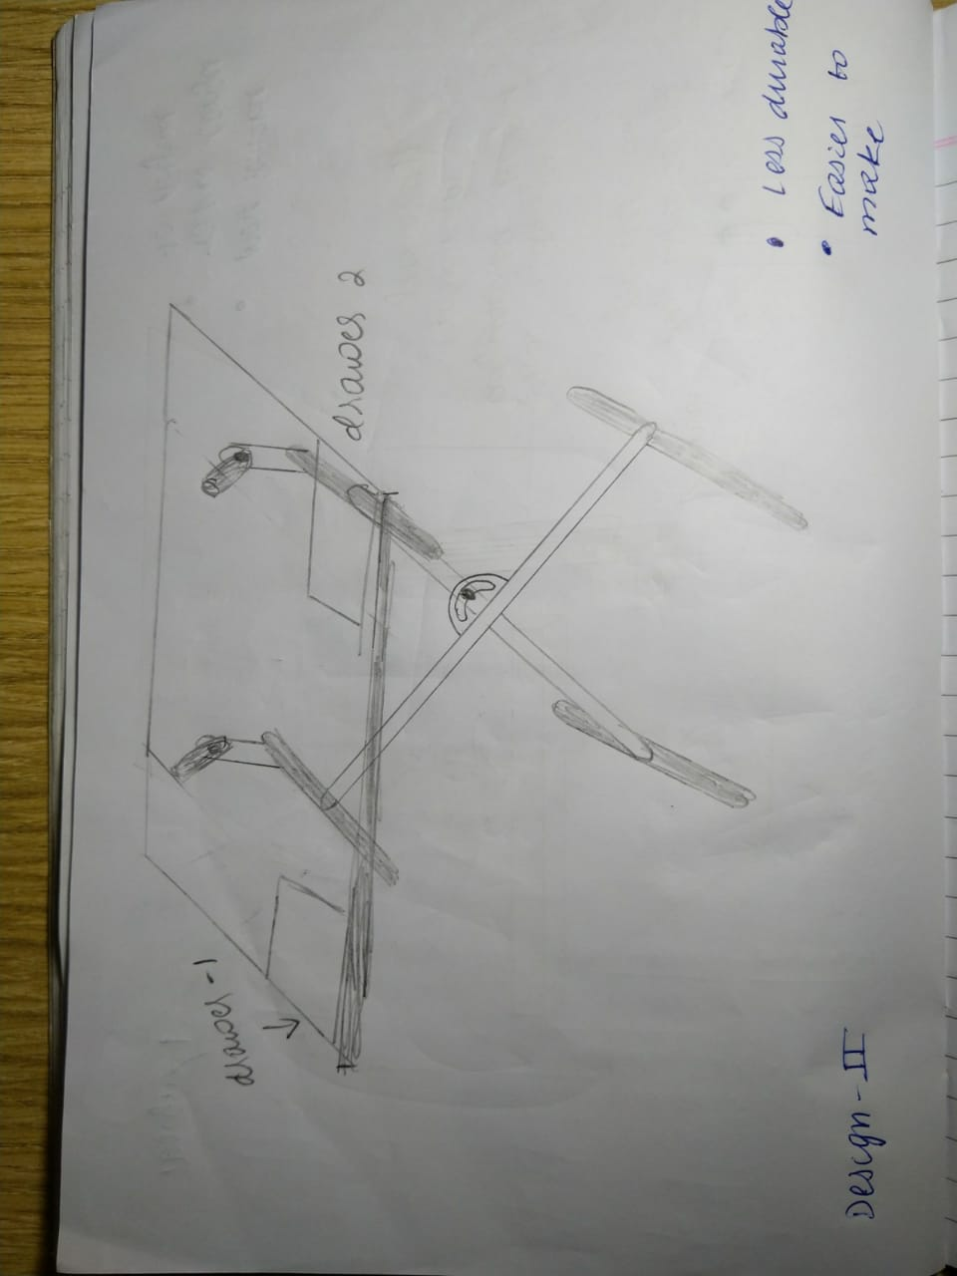

- 3D design made on Tinker CAD

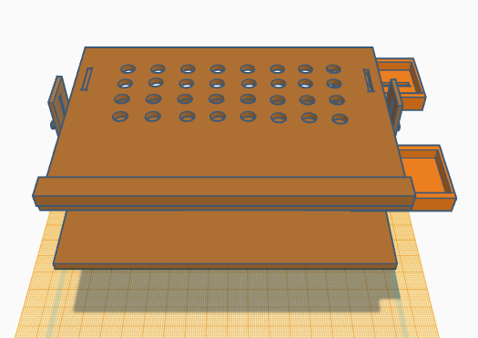

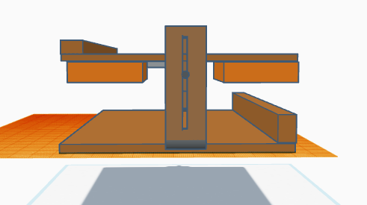

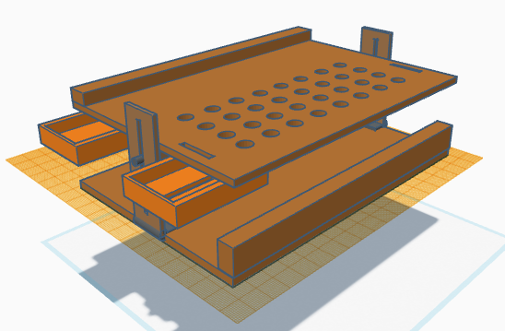

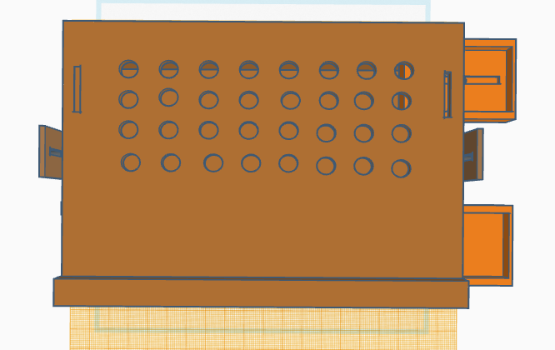

- Final Concept Sketch:

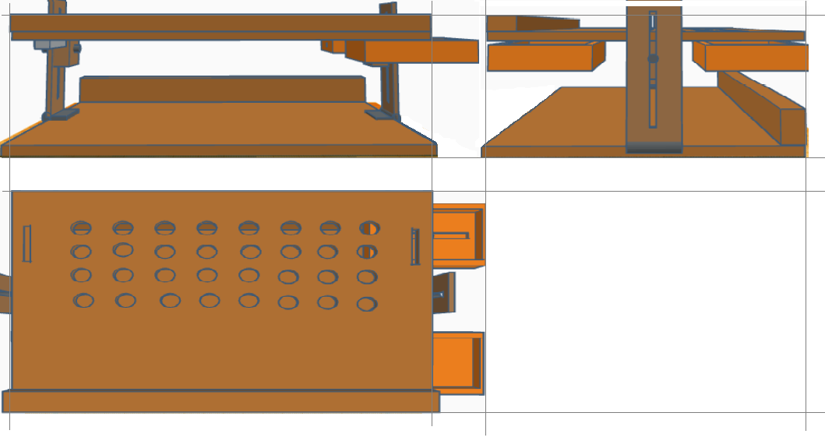

- Manufacturing Process:

- Materials used: The following materials were used:
- Pine wood for table top, base, drawers and folding legs.
- Aluminium strips for holding drawers in place and providing a sliding mechanism.
- Two Hinges for providing ‘folding’ feature to the legs.
- Two pairs of bolts and flying nuts for holding the table top in place at a desired height and angle.
- Fevicol and nails for joining smaller pieces of wood to make the base and top.
- Clear varnish for providing a finished look to the drawer.
- Two LED Lights (USB powered) to light up the keyboard/book.
- Two USB Male to Female cables.
- One USB 1:4 hub.
- Fevikwik to attach all the electronic components to the table top.

- Tools used: The following tools were used:
- Wood saw
- Hack saw
- Drill machine (12mm, 3mm bits)
- Router
- Sander
- Shearing machine
- Chisel
- Rasp
- File
- Belt sander
- Sandpaper
- Table vice
- C-clamps
- Screwdriver
- Hammer
- Plier
- Face mask
- Safety goggles
- Steel scale
- Pencils

- Process:

After finalising all measurements, we used pine wood from the lab to make the main two structures. We cut the wood with the rasp file and wood saw, filed it with the chisel with the help of the table vice. Since small pieces of wood were available in the lab, we stuck several pieces of wood with fevicol and nailed them together to get the desired structures. We filled all gaps with feviquick and saw dust. Similarly, we made the two drawers. We made the perforations on the top board with the 12mm drill machine and cut out the grooves in the drawers and table to with the router. We did the wood finishing using sand paper, sander and the belt sander. Next, we made the frame for the drawer using the aluminium strips. We used the shearing machine to cut the metal strips. After this, we made the leg structure using hinges. The desired height of the table could be fixed using the flying nuts and bolts structure. We polished our product using clear varnish and left it to dry. Lastly, we added the electronic components.

- Budget:

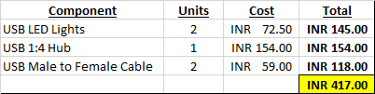

Apart from this all the materials and tools were available in the lab. However, according to our finding pine would is best available at around Rs. 400 per cubic feet which is the main material used.

- Conclusion and scope for further improvement:

This being our first ever hands-on project and not having any prior exposure to working in a design lab, there were obviously some roadblocks we faced. Although we are very proud and happy of what we have made, we realise that it is still a prototype and there can be further improvements and optimisation to the same, to make it a better product.We also believe that a market exists for this product and it can actually serve the needs of a large fraction of the consumer base.
Some of the observations and hurdles we encountered were:

- If the structure could be made of lighter material such a hard plastic, it would be less bulky and heavy. However, that was beyond our scope and reach.
- It could be made a little smaller so that it’d fit in a regular bag. However, that limits the space for all the components that needed to be added. Hence, a perfect balance between size and portability needs to be struck for the best results.
- The hinges we used we not strong enough and caused the table to be unstable. We needed to add blocks of wood on either side of the legs to solve this issue. Newer versions of the model should have stronger and heavier hinges.
- It is very difficult to make long slits using the router and the milling tool (not available in the design lab) should be used ideally.
- The height of the workstation after ‘folding’ is slightly more than what we had anticipated and can in part be attributed to the fact that the legs and the blocks that attach the legs to the top sit on top of one another. This could be improved by creating a depression in the base for the legs or by reducing the height of the blocks.
- Bending the metal sheets for the structure of the drawer was no easy task and a method needs to be identified to do the same more efficiently and neatly.

Overall, we thoroughly enjoyed the experience and feel a deep sense of satisfaction and pride in submitting our project and report.
Thank you.

